Statistics Lecture 4.2: Introduction to Probability

Low Probability means unusual/rare occurance.

Vocabulary:
Event: A collection of outcomes based on a procedure.
Simple Event: A single outcome.
Sample Space: All Simple Events (every possible outcomes)

Example:
Procedure: Event: Sample Space
Flipping a coin once Heads {Head/Tail}
Flip coin 3 times. 1 head/2 Tails HHH, HHT
3 Outcomes HTH
HTT
TTT, TTH
THT
THH

Flip coin 3 times. 1 Tail/2 Heads HHH, HHT
3 Outcomes HHT
HTT
TTT, TTH
THT
HHT

Flip coin 3 times. 3 Heads HHH, HHT
1 Outcomes HHT
HTT
TTT, TTH
THT
HHT

Flip coin 3 times. 3 Tails HHH, HHT
1 Outcomes HHT
HTT
TTT, TTH
THT
HHT

Probability: The likelyhood of an event occuring
Probability: 
Event: 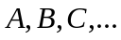
P(A) = the probability of Event A happening.

3 types of Probability
- Observed probability : (what did happen)
Estimated based on observation of a series of events.
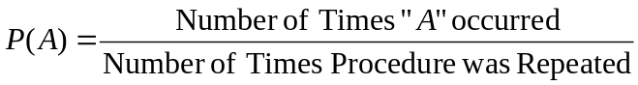

- Classical probability : (what should happen)
Chance of an event occurring. (each simple event must have an equal chance of occuring,

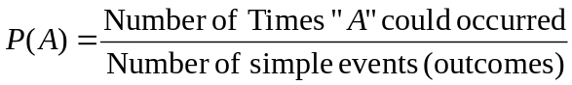

- Subjective probability : (what should happen)
Estimate based on an educated guess

Example
The probability of selecting a Heart ♥ from a standard deck of cards.
P(♥)=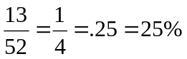 (classical) should happen.
Example
Flip coin 100 times and you get 64 Tails.
P(T)=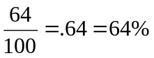 (Observed) Did happen.

Example
Peyton Manning completed 385 out of his first 528 passes.
Find the probability that Peyton Manning will complete a pass..
P(completing a pass)=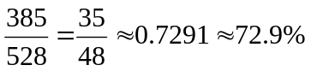 (Observed) Did happen.
Observed Probability.

Example
From a deck of cards. What is the probability of randomly selecting a 2.
Find the probability that Peyton Manning will complete a pass..
P(2)=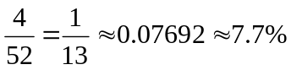 (Classical ) Should happen.
Classical Probability.

Example
Poll:
91 people said cloning was a good thing.
901 people said cloning was a bad thing.
20 people did not have an opinion

Find the probability of randomly selecting a person who thinks cloning is a good thing,.
P(cloning Good)=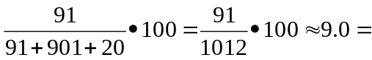
Observed Probability.

Example
Find the probability a bird will poop on your car today. (subjective)

Example
Find the probability that if a couple has 3 children, two will be boys.
Equal chance of boy or girl
Procedure: having 3 children. Event: 2 boys, 1 must be a girl
Sample Space: (simple Events)
{
BBB, BBG, BGB, BGG
GGG, GGB, GBG GBB
}
P(2B,1G)==.375=37.5%

Probability are always 0 and 1
P=0 impossible event
P=1 Certain event (always happens)

Law of large number. The more a procedure is repeated the closer the observed probability will get to
Classical probability.

Complementary Events.
Events are mutually exclusive. (cannot happen at the same time)

Complement the complement of event A is denoted and all outcomes when event A does not occur.

Example
Event: rolling a 5
Complement of above is Not rolling a 5 {1,2,3,4,6}

P(5)=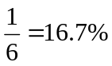
P()=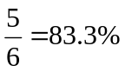
P(5)+P()=1

The probability of an event plus the complement of the event must equal 1

